1. create all given tables

Answer::

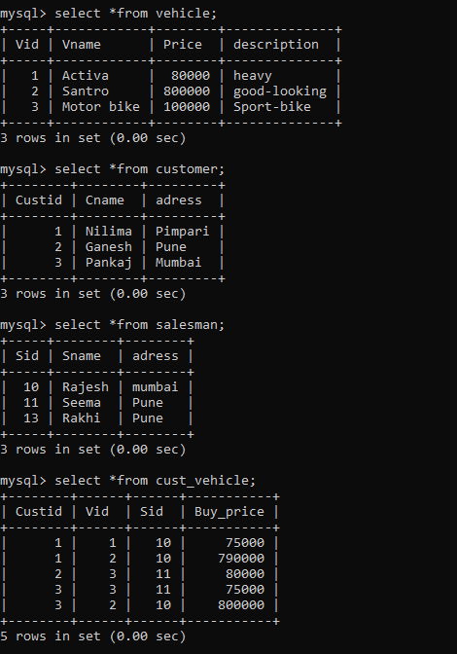

1. create index on vehicle table based on price

Answer:: **create index idx_vehicle on vehicle(price);**

**show indexes from Vehicle;**

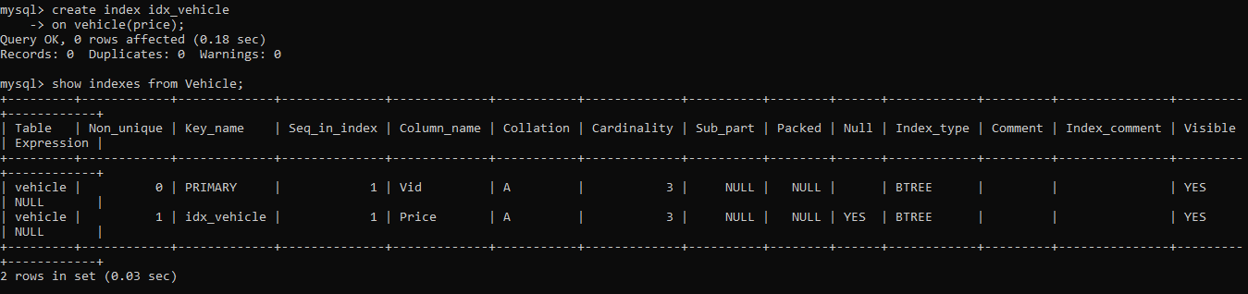

1. find all customer name,vehicle name, salesman name, discount earn by all customer

Answer::  **select cname,vname,sname,(price-Buy_price) Discount**

**from cust_vehicle cv inner join customer c**

**on cv.custid=c.custid**

**inner join Vehicle v**

**on cv.vid=v.vid**

**inner join Salesman s**

**on cv.sid=s.sid;**

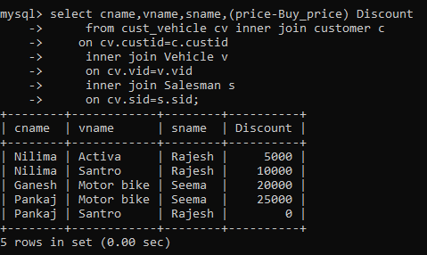

1. find all customer name,vehicle name,salesman name for all salesman who stays in pune

Answer:: **select cname,vname,sname,s.adress**

**from cust_vehicle cv inner join customer c**

**on cv.custid = c.custid**

**inner join vehicle v**

**on cv.vid=v.vid**

**inner join salesman s**

**on cv.sid = s.sid**

**where s.adress = 'Pune';**

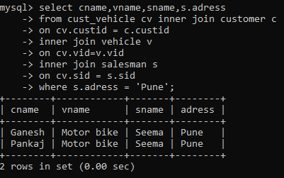

1. find how many customers bought motor bike

Answer:: **select count(*) from cust_vehicle cv**

**inner join customer c**

**on cv.custid=c.custid**

**inner join vehicle v**

**on cv.vid=v.vid**

**where vname ='motor bike'**

**group by v.vid;**

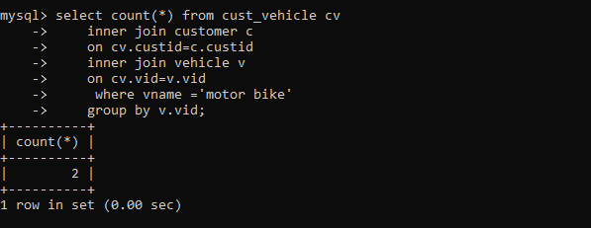

1. . create a view find_discount which displays output

Answer:: **create view find_discount**

**as**

**select cname,vname,price,buy_price,price-buy_price “discount”**

**from customer c inner join cust_vehicle cv on c.custid=cv.cid inner join vehicle v on**

**v.vid=cv.vid**

**--------to display discount**

**select * from find_discount**

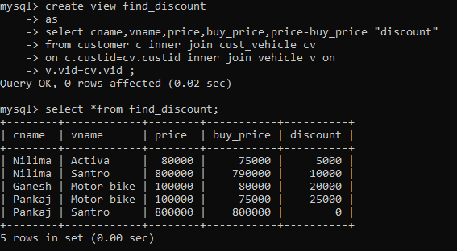

1. find all customer name, vehicle name, salesman name, discount earn by all customer

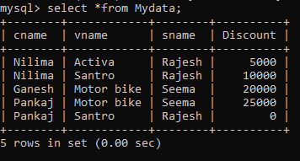

1. create view my_hr to display empno,ename,job,comm for all employees who earn commission

Answer :: CREATE view my_hr2

as

select empno,ename,job,comm from emp

where comm is not null and comm != 0;

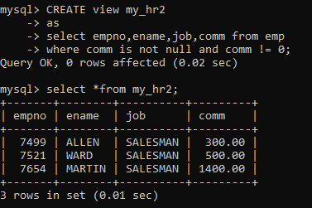

1. create view mgr30 to display all employees from department 30

Answer:: CREATE view mgr30

as

select *from emp

where deptno = 30;

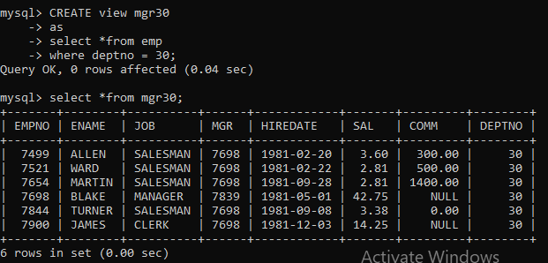

1. insert 3 employees in view mgr30 check whether insertion is possible

Answer:: insert into mgr30 values(7777,'Kajal','Manager',NULL,'2023-01-

01',85.78,NULL,30),

(788,'Harshada','QA','7777','2024-01-01',50.00,4000,20),

(7730,'Utkarsha','Analyst',7698,'2023-02-20',88.78,null,30);

select * from mgr30;

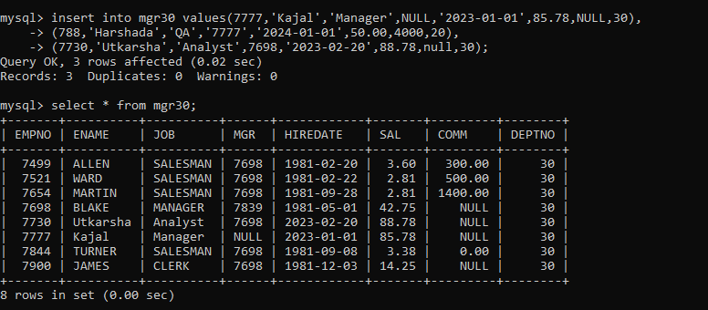

1. insert 3 records in dept and display all records from dept
2. use rollback command check what happens

13. do the following

insert row in emp with empno 100

insert row in emp with empno 101

insert row in emp with empno 102

add savepoint A

insert row in emp with empno 103

insert row in emp with empno 104

insert row in emp with empno 105

add savepoint B

delete emp with empno 100

delete emp with emp no 104

rollback upto svaepoint B

check what all records will appear in employee table

rollback upto A

check what all records will appear in employee table

commit all changes

check what all records will appear in employee table

check whether you can roll back the contents.

14. create a procedure getMin(deptno,minsal) to find minimum salary of given table.